Axis Vistara Signature

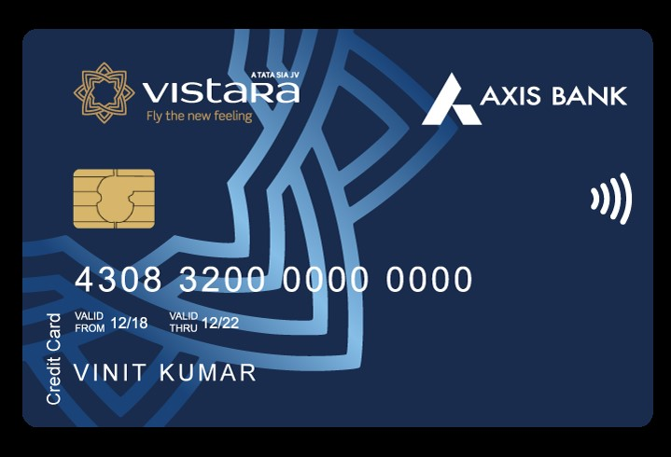

Benefits of Axis Vistara Signature Credit Card

* Welcome Offer: FREE Premium Economy Vistara Flight Ticket. Continue to enjoy this benefit on renewal of your credit card membership every year. For T&Cs, check : https://www.axisbank.com/docs/default-source/default-document-library/terms-and-conditions-for-axis-bank-vistara-credit-cards-ticket-voucher-benefit.pdf
* Complimentary Club Vistara Silver Membership – priority check-in, additional baggage allowance , on fee payment. This membership will be issued within 10 working days of joining or annual fee payment
* Get 4 CV points on every Rs 200 spent from this card, not applicable on Fuel, EMI, Rent, utility bills, wallet load, government transactions.
* Get Up to 4 Free Premium Economy Tickets on achieving Milestone Spends. To know more , please check : <https://www.axisbank.com/retail/cards/credit-card/axis-bank-vistara-signature-credit-card>.
* Enjoy 2 Quarterly Complimentary domestic lounge visit on Select Airports. Check here: <https://www.axisbank.com/docs/default-source/default-document-library/axis-bank-airport-lounge-access-program.pdf>
* 3 Complimentary rounds of golf at some of India’s picturesque destinations. For details, click: https://www.extraordinaryweekends.com/golf/

How to Apply for Axis Vistara Signature Credit Card

* User click on the CTA Button or tracking link
* User click Login/Join Now and do OTP verification
* He/she Select Axis Vistara Signature Credit Card and provide the required details
* User’s application will be submitted, and a confirmation SMS will be sent on approval of user’s application
* User get his/her application status within 10 minutes

Documents required for the application

* ID Proof
* Address Proof
* Income Proof
* PAN Card

Eligibility Criteria

* Employment status: Salaried or self-employed
* Income: Rs 50,000 per month (Salaried)
* Rs 60,000 per month (self-employed)
* Required Age: 21-65 years

Fees and List of all Charges

* Joining Fees: Rs 3000 + GST
* Annual Fees: Rs 3000 + GST
* Interest rate: 3.6% per month
* Cash Withdrawal charges: 2.5% or Rs 500, whichever is higher
* Card Replacement charges: Nil

Important Information

* If user’s Card is disbursed, you will be eligible for Commission
* No commission if Application is Rejected